MS Office Excel (Project 5B)
Welcome back! In my next tutorial, I used sorting and filtering features.

On the first worksheet, “Room Conflicts”, I selected the range from A1 to M50, navigated to the “Insert” tab, went to the “Tables” group, and clicked “Create Table”. When I clicked “Create Table”, I got a “Create Table” pop-up window.

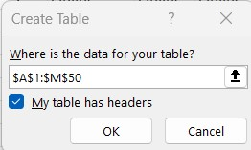

When I click “OK”, I get a table with headers. I navigated to the “Design” tab, went to the “Table Styles” group, clicked “More”, and selected “Table Style Light 16” under “Light”.

Now that I created my table, I’m ready to use the sort and filter features. Sorting data helps me quickly visualize and understand my data better, organize and find data I want, and make effective decisions. I navigated to the “Data” tab, went to the “Sort & Filter” group, and clicked “Sort”. When I clicked on “Sort”, I got a “Sort” pop-up window.

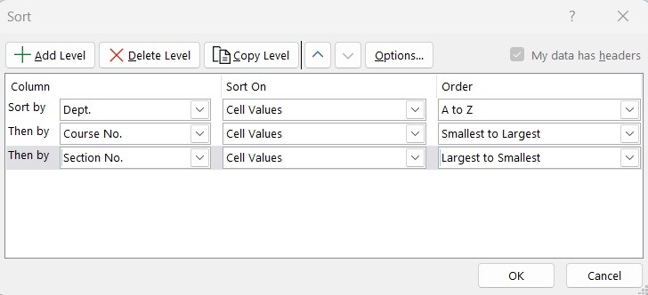

When I clicked “OK”, the first level is by the Dept. field in alphabetic order, the second is by the Course No. field in ascending order (in each department, the courses are sorted in ascending order by course number), and the third sort level is by the Section No. field in ascending order.

I can also use a custom list to sort in the order that I define. Excel includes a day-of-the week and month-of-the-year custom list, so that I can sort chronologically by the days of the week or by the months of the year from January to December. I can create my own custom list by typing the values I want to sort by, in the order I want to sort them. I selected the “Online-Campus” worksheet, navigated to the “Data” tab, went to the “Sort & Filter” group, and clicked “Sort”. I still get the same “Sort” pop-up window when I set the “Sort by” to “Delivery”.

But what’s different here is that instead of leaving the default option as “A to Z” for “Order”, I selected “Custom List”. When I selected “Custom List”, I got a “Custom Lists” pop-up window.

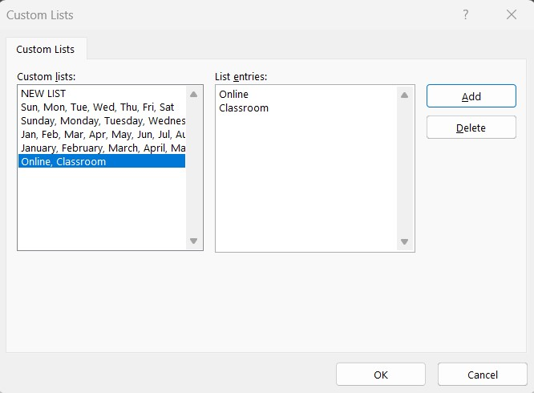

After I typed “Online”, pressed “Enter” and typed in Classroom”, I selected “Add” to add “Online, Classroom” to the list of “Custom lists”. When I clicked “OK”, I can see that the “Classroom” sections start on row 92.

Filtering displays only the rows that meet the criteria in terms of conditions that I set to limit which records are included in the results and hides the rows that do not meet my criteria. When I format a range of data as a table, or select a range and click the Filter command, Excel shows filter arrows in the column headings and that’s where I can filter a column by a list of values, format, or criteria. I can use a custom filter to apply complex criteria to a single column or an advanced filter to specify at least three pieces of criteria for a specific column or apply complex criteria to two columns. I can use an advanced filter for extracting by copying the selected rows to another part of the worksheet, instead of displaying the filtered list. In the “CIS & CPS' and “Database-Linux” worksheets, my columns have arrows. So, when I click on the arrows, I can filter out certain information.

I went to the “Faculty Advising” worksheet, selected the range from A7 to G7, copied it and pasted it in the range from A2 to G2. In cell D3, I typed “>=70000”. This means that I want Excel to look for salary values that are greater than or equal to $70,000. I clicked on cell A7, navigated to the “Data Tab”, went to the “Sort & Filter” group, and selected “Advanced”. When I clicked “Advanced”, I got a “Advanced Filters” pop-up window.
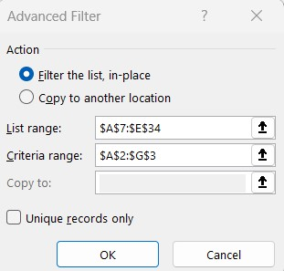

Both the List and the Criteria ranges use absolute cell references. That’s because I don’t want the values to change when Excel looks up the criteria to filter out. When I click “OK”, I can see that 11 entries have pulled up. I added another piece of Criteria when I typed in “*Professor” in B3 and this will give me only records, where the classification equals “Professor”. Then, I navigated to the “Formulas” tab, went to the “Defined Names” group, and clicked “Name Manager”. In the list of names, I selected “Criteria”, chose “Delete”, clicked “OK”, and cleared my filters.

I can extract data and pull out the results of a filter to another area of my worksheet. The location where I copy records to is the Extract area, which is below the table of data. In the “Schedule Comparison” worksheet, I copied the range from A2 to G2 and pasted it in row 37. Then, I set the name for the range as “Extract”. I repeated this step for the range of A7 to G34, but this time, I named the range as “Database”. In cell E3, I typed “Morning”. Then in cell F3, I typed “Evening”. Next, I selected the range from A7 to G34, navigated to the “Data” tab, went to the “Sort & Filter” group, and chose “Advanced”.

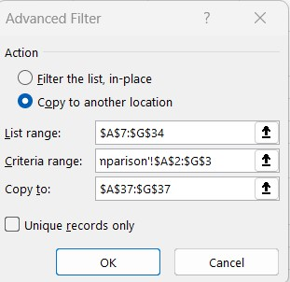

When I clicked “OK”, two records met the criteria and were in the extract area of my worksheet.

The final step was to group and summarize a list, a series of rows that contains related data, by adding subtotals. In the “Salaries by Department” worksheet, I selected the range from A2 to G29, navigated to the “Data” tab, went to the “Sort & Filter” group, and chose “Sort”. In the “Sort” pop-up window, I set the first sort to “Dept.” and the second to “Annual Salary”. After I clicked “OK”, I navigated back to the “Data” tab, went to the “Outline” group, and clicked “Subtotal”. When I clicked “Subtotal”, I got a “Subtotal” pop-up window.

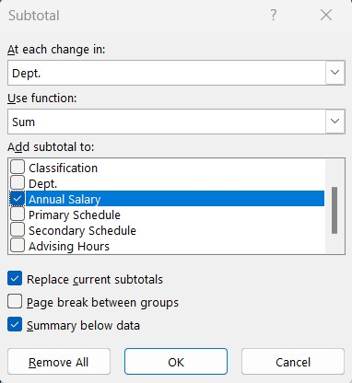

In the “Subtotal” pop-up window, I set “At each change in” to “Dept.”, “Use function” to “Sum” and checked off “Annual Salary” for “Add subtotal to” check box and deselected all the other check boxes. These actions told Excel to create a group for each change in value in the Dept. field. Then, Excel will use the Sum function to add a subtotal in the Annual Salary field. The check boxes at the bottom of the pop-up window will show how the subtotals will display. When I clicked “OK”, I got an outline bar. The outline bar along the left side of the worksheet lets me show and hide levels of detail with one click. I can show details with the totals, which is the default view or only the summary totals or only the grand total. There are three types of controls in the outline. Hide Detail (–) collapses a group of cells, Show Detail (+) expands a collapsed group of cells, and the level buttons (1, 2, 3) can hide all levels of detail below the number clicked.

So, this is how I used advanced sorting and filtering features. Hope this tutorial was helpful and I’ll see you in the next one!

